INTRODUCTION
In the modern era of rapid urbanization and increasing energy demands, the efficient use of electricity has become a global priority. Lighting accounts for a significant portion of energy consumption in residential, commercial, and industrial sectors. Often, lights are left running in unoccupied rooms or during daylight hours due to human negligence. This project, “Automatic Light Using LDR & IR Sensor,” aims to tackle this inefficiency by creating an intelligent lighting system that operates autonomously based on environmental conditions.

The system utilizes two primary sensors: a Light Dependent Resistor (LDR) to monitor ambient light levels and an Infrared (IR) sensor to detect human presence. By integrating these sensors, the system ensures that the light turns on only when it is dark and a person is actually in the room. This dual-sensing approach moves beyond simple timers or manual switches, offering a sophisticated solution for smart energy management. This project not only serves as a cost-effective automation tool but also contributes significantly to reducing the carbon footprint by minimizing unnecessary power consumption.

METHODOLOGY
The methodology of this project centers on conditional logic and sensor integration through a microcontroller, typically an Arduino. The core principle is an “AND” logic operation: the light should activate only if it is dark AND motion is detected. The process begins with the LDR sensor, which acts as a variable resistor whose resistance decreases as light intensity increases. The microcontroller reads the analog voltage from the LDR; if the value falls below a pre-set threshold (indicating darkness), the system proceeds to the next check.

Simultaneously, the IR sensor emits infrared
Radiation. When a person enters the detection range, the IR waves reflect off the body and are captured by the sensor’s receiver. This sends a digital “HIGH” signal to the microcontroller. The software is programmed to trigger a Relay module only when both conditions are met. The Relay acts as an electromagnetic switch, allowing the low-power DC circuit of the microcontroller to safely control the high-power AC supply of a standard household bulb. Once motion is no longer detected, the system waits for a programmed delay period before switching the light off to prevent frequent flickering

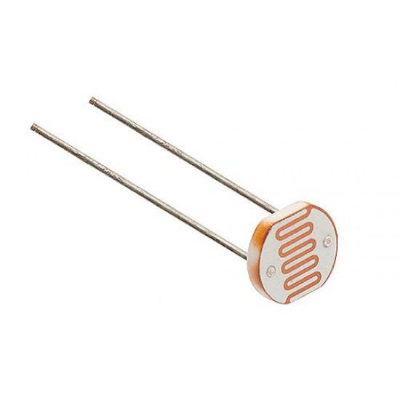
COMPONENT

1.LDR

Resistor

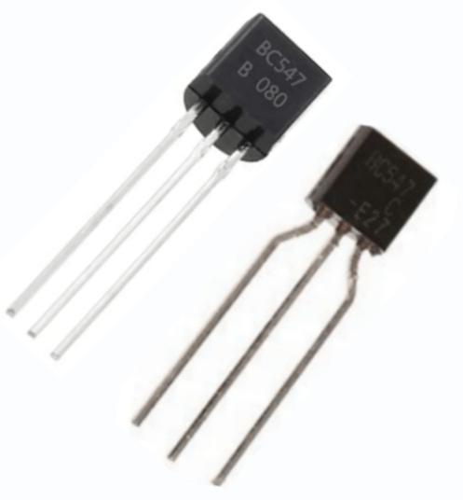
BC 547 Transistor


9v battery


Connecting wires

4. Advantages and Applications

The combination of LDR and IR sensors offers

Numerous advantages over traditional lighting. The most prominent benefit is Energy Efficiency; by automating the “Off” state, the system ensures that no energy is wasted during the day or in empty spaces. Secondly, it provides Enhanced Convenience, especially in areas like staircases, hallways, or bathrooms where finding a manual switch in the dark can be difficult or hazardous. Furthermore, it increases the Longevity of Bulbs by reducing their total operation time. 9:27 pm✓
The applications for this technology are vast. In Residential Smart Homes, it can be used for porch lights that turn on only when someone approaches at night. In Commercial
Offices, it ensures that meeting rooms and restrooms are lit only when occupied. Street Lighting is another major application; cities can implement these sensors to dim or turn off street lights on deserted roads, saving massive amounts of municipal electricity. It is also highly useful in industrial warehouses where workers may have their hands full and cannotOperate manual

5. Results

The implementation of the prototype yielded successful results in a controlled environment. During the testing phase, the system was subjected to various lighting conditions and movement patterns. In bright daylight, the light remained consistently OFF, regardless of whether a person moved in front of the IR sensor, proving the effectiveness of the LDR’s threshold settings. When the ambient light was blocked (simulating nighttime), the system remained in standby mode until the IR sensor detected movement within

A 2-meter range

Upon detection, the relay clicked instantly, and The bulb illuminated. The system also demonstrated stability; it did not suffer from “false triggers” from minor shadows or temperature changes. The transition from ON to OFF was smooth, with a programmed 10-second delay that ensured the light didn’t shut off if a person was momentarily still. These results confirm that the integration of two distinct sensor types creates a more reliable and “smarter” automation system than using a single sensor

6. Future Scope

While the current project is a functional prototype, there is significant room for future enhancement. One major upgrade would be the integration of loT (Internet of Things) capabilities using a Wi-Fi module like the ESP8266. This would allow users to monitor energy consumption and control the lights remotely via a smartphone application. Another improvement would be Brightness Control (Dimming); instead of a simple On/Off relay, a Triac circuit could be used to dim the lights based on the exact amount of darkness, providing just enough light as needed.
Additionally, the IR sensor could be replaced or supplemented with a PIR (Passive Infrared) sensor, which has a much wider detection angle and is better at detecting human body heat over longer distances. Future iterations could also incorporate Machine Learning to “learn” the occupancy patterns of a room, pre-emptively lighting up areas based on historical data. Finally, integrating a Solar Charging unit would make the entire system self-sustainable and completely off-grid, ideal for outdoor or rural

7. Conclusion

The “Automatic Light Using LDR & IR Sensor” project successfully achieves its goal of providing an intelligent, energy-efficient lighting solution. By utilizing the synergistic properties of light sensing and motion detection, the system effectively eliminates the human error associated with manual switches. The project proves that sophisticated automation does not necessarily require expensive equipment; rather, it requires the clever application of basic electronic principles and logic.
In conclusion, this system is a practical response to the need for sustainable living. It addresses the core issues of energy conservation and user convenience in a single, compact design. As we move toward a future defined by “Smart Cities,” such autonomous systems will become the standard rather than the exception. Implementing this project on a larger scale could lead to significant reductions in global energy consumption, making it a vital contribution to both technology and environmental preservation.

8. Reference

The development of this project was supported by various technical resources and literature:

The Art of Electronics by Paul Horowitz and Winfield Hill - for understanding sensor interfacing and relay logic.

Arduino Programming Notebook by Brian Evans - for code structure and microcontroller logic.

Official Arduino Documentation (arduino.cc) - for pin configurations and library functions.

Energy Efficient Lighting Systems by Steven Mesick - for data on energy savings through automation.

Online technical forums such as Electronics Hub and Instructables for circuit design optimization and troubleshooting.

Data Sheets for the HC-SR501 IR sensor and the standard 5mm LDR for voltage and sensitivity specifications.

